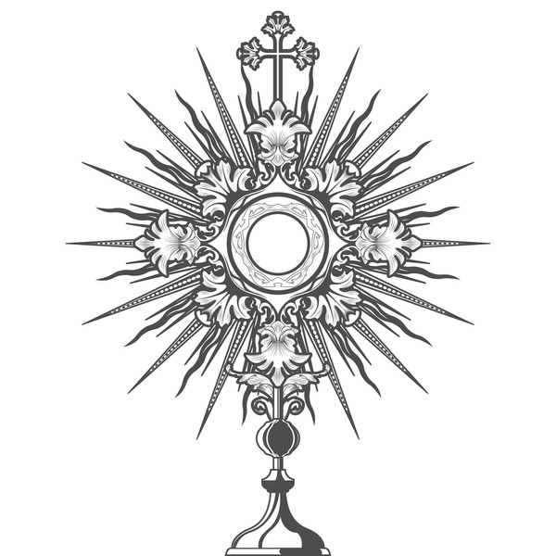
The Feast of Corpus Christi celebrates the abiding presence of Jesus Christ in the Holy Eucharist, reminding us that God remains with us as Emmanuel— “God with us” (Matthew 1:23). Among Christ’s final gifts to humanity were the Holy Eucharist, given on Holy Thursday as our spiritual food, and Mary, entrusted to us on Good Friday as our spiritual Mother.
Our faith in the Real Presence of Jesus in the Eucharist is rooted in His own words: “I am the living bread that came down from heaven; whoever eats this bread will live forever” (John 6:51), and at the Last Supper, “This is my body… this is my blood” (Matthew 26:26–28). Through the mystery of transubstantiation, the bread and wine become the Body and Blood, Soul and Divinity of Christ, while their outward appearances remain unchanged.
The saints have continually affirmed this truth. St. Thomas Aquinas wrote, “No other nation has God so near to it as we are, for He is present in the Eucharist.” St. Teresa of Calcutta reminded us, “When you look at the crucifix, you understand how much Jesus loved you. When you look at the Eucharist, you understand how much He loves you now.”
As we celebrate Corpus Christi, may we receive Jesus with reverence and gratitude and become Christ-bearers, sharing His love, mercy, forgiveness, and humble service with all whom we meet.
Fr. Jackson Sebastian
Sunday 7th June
THE MOST HOLY BODY AND BLOOD OF CHRIST (CORPUS CHRISTI) (A)
8 am - 8.20am Confession
8.30 am Mass
10 am - 10.20 am Confession
10.30 am Mass
Andy Anderson, RIP (Suzanne Philips)
Tuesday 9nd June
Feria
6 pm Mass
Cathy Anderson’s Intentions
Wednesday 10th June
9.30 am Adoration & Rosary
10 am Mass
Mrs. Nancy Morriss RIP
(McCarthy Family)
Thursday 11th June
9.30 am Adoration & Rosary
10 am Mass
Private Intention
Friday 12^{h} June
9.30 am Adoration & Rosary
10 am Mass
People of the Parish
Saturday 13th June
5.30 pm - 5.50pm Confession
6 pm Vigil
Anthony Andrew Tunney (FM)
Sunday 14th June
Eleventh Sunday
8 am - 8.20 am Confession
8.30 am Mass
Andrew McLoughlin, RIP(FM)
10 am - 10.20 am Confession
10.30 am Mass
Liz & Gordon McKay, 30th Wedding Anniversary
(Sheila Murray)

Parish Events - Dates for your Diary
Friday, 26th June - Summer Cream Tea
Saturday, 4th July - SVP Quiz Night

Please turn over for more news

In Memoriam
We continue to pray for the souls of our recently deceased parishioners and those whose anniversaries fall at this time.
John Maharry, RIP
Andy Anderson, RIP
May they rest in peace and rise in glory, Amen.

This Week Please Pray for…
Our parish Secretary Louise Hailey.
All who are lonely, sick or housebound in our parish.
If you, or a relative are ill and would like to be added to this section by name please contact the parish office in writing confirming you have permission to publish their name online. Thank you.

In the Parish Hall this Week …
Sunday 7th June - 11.30 am
Refreshments after 10.30 am Mass. All are welcome.
Thursday 11th June - 7.15 pm
Parish Bible Study - the God who speaks…
All are welcome to come and explore the Gospel reading for the following Sunday. Please bring a Bible if you have one.
Friday 12th June - 5pm -6.30pm
Rise Up Youth Club - ages 13-17 welcome
Pizza, Games & Fun

Time and Talents
Please feel free to join any of our volunteering roles we can always use more help with readers at Mass, tea/coffee makers, collection counters, greeters and leaders for Children’s liturgy. If you would like to know more about these roles please contact Louise in the office Tuesdays - Thursdays 9.30 - 3.30.

Coffee Morning in aid of the SVP
Tuesday 23rd June 10 o’clock till 12 o’clock at Frances’s house.
For details email frances.tunney@yahoo.co.uk Or ask any of the SVP team.

Parish Anniversaries this week…
Happy Birthday to Evelyn Dickinson
Please let the parish office know of any birthday or wedding anniversaries that are coming up so that we may celebrate and pray together.

Calling All Singers and Musicians
If you love singing or you play, or are learning an instrument whatever age you are we would like to here about it! Please speak to Fr Jackson.

